______________________________________________________________

UM-SJTU JOINT INSTITUTE

SINGALS AND SYSTEMS

(VE 216)

______________________________________________________________

LABORATORY REPORT

LAB 3

Feedback Control

|  |  |  |
| --- | --- | --- |
| Name: **Weikai Zhou** | ID: **518021911039** |  |
| Date: 2 Agust 2020 |  |  |

1. **Objectives**

* Build open loop control and feedback control circuit and understand feedback control.

1. **Theoretical Background**
   1. **Introduction**

In this laboratory project we will develop the idea of feedback control, the process of adjusting the input to a system as a function of a measured variable so as to obtain a desired response. Stated like this, the concept seems very vague, almost as vague as the notion of a system seemed to you in the first f e w weeks of this course. We will try to make the notion of feedback control more precise by looking at a particular example, the idle speed control loop in your car. After that, we’ll discuss different kinds of control.

When you press on the accelerator pedal of your car, the engine produces more power. When you take your foot off the pedal, the engine does not stop, rather, it runs at a fixed ideal speed, such as 750 RPM (revolutions per minute). Moreover, the engine maintains a constant idle speed even when the power load on the engine changes, such as when the air conditioner cycles on or off, or, assuming you have your foot on the brake, when you shift the transmission from park to neutral to drive. How is it possible for the engine to idle at a fixed speed under a variety of loads? The answer is feedback control. A sensor measures the speed of the engine and a “mechanism”, called a feedback controller, automatically adjusts the power requested from the engine so as to maintain a constant idle speed.

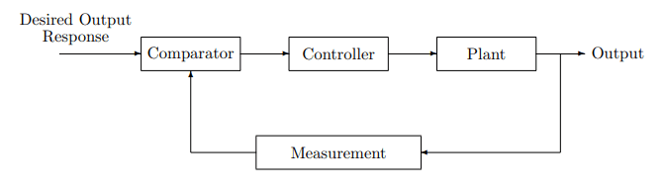The engine system illustrates all the basic components of what we call a *feedback control system*. The key elements are: (i) A measured Quantity that is to be regulated to a desired value (e.g., engine idle speed); this is typically defined to be the *system output*; (ii) An *input* that can be varied so as to change the value of the output (e.g., throttle position); (iii) An element that determines how to adjust the input so as to drive the output to a desired value; this element is called the *controller*. The overall system is shown in Figure 1, where the comparator computes the error between the desired output value and the current output value, and the controller seeks to drive this error to zero. Such a feedback control system is also known as a closed-loop control system due to the closed signal path that connects all four components (e.g., Comparator to Controller to Plant to Measurement to Comparator).

Figure 1. Closed-loop control system

In a feedback control system, information from the observed output of the system is used to modify the system’s input and, consequently, alter the system output. The controller is designed to adjust the input to the plant, based on the current output signal, in order to achieve a desired output signal. Feedback control systems are widely used and can be found in almost every consumer product that involves electronics, including ovens, computer hard drives, CD players, cellphones, automobiles, etc. Of course, there are many non-electrical control systems, too. The human body contains a host of complex biologically-based feedback control systems. These systems control everything from your heart rate to your ability to breathe, swallow and walk.

Control systems do not always require feedback. Sometimes one just needs to regulate the sequence in which events occur, such as when coins inserted into a vending machine cause a selected product to be delivered and the correct change to be computed and returned to the customer. This type of control is called *sequential control* or *discrete-event control*.

Another type of non-feedback control is used in situations where measurements are hard to make, or the economic cost of adding the necessary sensor to the system is too high. In these situations, the controller computes the input to the plant on the basis of the desired output alone, by using a *mathematical model* of the system to determine the correct input. Such a control method is called open-loop control for the obvious reason that the loop depicted in Figure 1 is no longer present because nothing is measured! You may be surprised to learn that the icon of high-tech industries, semiconductor chip manufacturing, is largely based on open-loop manufacturing processes. For example, the amount of microwave power applied to a reactive ion etcher is typically determined ahead of time by careful experimentation to deliver a given etch rate on the assumption that the machines being used are extremely repeatable from one manufacturing run to the next.

Although not all control systems utilize feedback control, many do. In an environment where conditions change over time, disturbances are present, or an accurate model of the system is not available for precomputing the required control signal, it can be very difficult, if not impossible, to precisely regulate the system’s output using an open-loop control method. In these cases, adjusting the input as a function of a measured variable is more effective. *The use of feedback control reduces the need for a very accurate system model*.

Another reason for using feedback control is *stability*. Civilian aircraft are designed to be open-loop stable, meaning that even in the absence of feedback, the aircraft is BIBO stable, so that small changes to the control surfaces produce small changes in the aircraft’s pitch, for example. There are cases, however, where it would be useful if small changes in the control surfaces produce large changes in pitch. In combat situations for fighter aircraft, speed of response is often the difference between life and death. The F-16 was the first military craft to be deliberately designed to be open-loop *unstable*. In fact, to achieve the desired response speeds require, it is so unstable that human reflexes are too slow to achieve stability. A sophisticated digital feedback control system makes the system BIBO stable as well as highly maneuverable. On the downside, if a key actuator or sensor fails, the plane tumbles and disintegrates in less than a second!

In summary, feedback control allows (1) the output of a system to be regulated to a precise value in the absence of a precise system model or when the characteristics of the system change over time, and (2) an unstable system to be stabilized.

In the present laboratory, we will consider the control of LTI systems using LTI controllers. Furthermore, we will restrict our attention to systems that have only a single input and a single output and which operate in the absence of large external disturbances. We will find that Laplace transform (i.e., *s*-domain) tools are ideally suited to the analysis and design of linear feedback-control systems, and that the response of the system will be determined by the location of the poles and zeros of the closed-loop system transfer function. Basic concepts will be illustrated by constructing a PD (proportional-differential) feedback controller using operational amplifiers and by comparing the measured performance of the closed-loop system against theory.

* 1. **Preliminary Information**
     1. **A Closed-Loop Feedback Model**

The block diagram of a generic closed-loop feedback control system is shown in Figure 1. In this figure, the “plant” is the system whose output we wish to control. A measurement is performed on the output by the measurement sub-system, which is then compared with the desired output, i.e., the input to the control system. The output of the comparator, which computes the difference between the desired and the actual output, is fed into a controller whose output serves as the input to the plant. If the comparator and measurement system were removed from the above diagram then one would be left with an open-loop (i.e., no feedback) controller.

* + 1. **RLC Resonant Circuit (or the First Step in Selecting a Station)**

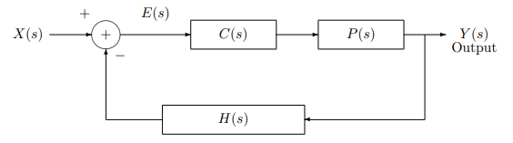As mentioned earlier, we will restrict our discussion to the case where all of the blocks shown in Figure 1 are LTI systems. Thus the input/output relationship of each of these blocks can be described by a system transfer function. Furthermore, we will realize the comparator as an adder and change the gain on the measurement to -1. With these changes, the block diagram of Figure 2 becomes:

Figure 2. Closed-loop control system (C: Controller, P: Plant, M: Measurement)

It is a simple matter of algebra to compute the closed-loop transfer function, $G_{cl}\left(s\right)=Y(s)/X\left(s\right)$, of the systems shown in Figure 1 as indicated below.

$$Y\left(s\right)=E\left(s\right)C\left(s\right)P\left(s\right)$$

$$E\left(s\right)=X\left(s\right)-H\left(s\right)Y\left(s\right)$$

Combining these two equations yields

* + 1. **Examples of Feedback Control Systems**
       1. **DC Motor Model**

Let us assume that we want to control the shaft position of a DC motor. To help design a controller for this DC motor, we mathematically model the angular position, *θ*(*t*) of the shift by the following differential equation

$$\frac{d^{2}θ\left(t\right)}{dt^{2}}+\frac{dθ\left(t\right)}{dt}=V(t)$$

where *V*(*t*) is the voltage applied to the motor. Thus the plant (i.e., the motor) is a LTI system that has the following system transfer function

$$P\left(s\right)=\frac{1}{s\left(s+1\right)}$$

This transfer function corresponds to a second-order LTI system with no zeros, and a pair of real poles located at the origin and at -1.

* + - 1. **No Controller**

Suppose we want the shaft of the motor to rotate by one radian per second by using a unit step as the input, i.e., *V*(*t*) = *u*(*t*). Then

$$θ\left(s\right)=V\left(s\right)P\left(s\right)=\frac{1}{s}\frac{1}{s\left(s+1\right)}=-\frac{1}{s}+\frac{1}{s^{2}}+\frac{1}{s+1}$$

where the right-most side is obtained by a partial fraction expansion. Consequently,

$$θ\left(t\right)=\left(t-1+e^{-t}\right)u\left(t\right)$$

which is clearly not going to achieve the desired rotation by one radian per second!

* + - 1. **Controller Without Feedback (i.e., Open-Loop Control)**

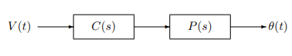Shown below (Figure 3) is the block diagram of an open-loop controller. We choose a differentiator as the controller,

Figure 3. Open-loop controller

i.e.,

$$C\left(s\right)=s$$

of a unit-step input. Thus

$$θ\left(s\right)=V\left(s\right)C\left(s\right)P\left(s\right)=\frac{1}{s}s\frac{1}{s\left(s+1\right)}=\frac{1}{s}-\frac{1}{s+1}$$

Therefore

$$θ\left(t\right)=\left(1-e^{-t}\right)u\left(t\right)$$

Clearly, $\lim_{t→∞}{θ\left(t\right)}=1$, so that this controller results in no steady-state error (i.e., *e*(t) = *V*(*t*) − *θ*(*t*) = 0 as *t* → ∞) when the input is a unit step. The response of the DC motor to the unit step, however, is rather slow. It takes approximately 2.3 s for the shaft angle to reach 90% of its final value of 1 radian.

We might ask how well this same controller would work if the input were a ramp rather than a step. Under such circumstances

$$V\left(s\right)=\frac{1}{s^{2}}$$

$$θ\left(s\right)=V\left(s\right)C\left(s\right)P\left(s\right)=\frac{1}{s^{2}}s\frac{1}{s\left(s+1\right)}=-\frac{1}{s}+\frac{1}{s^{2}}+\frac{1}{s+1}$$

Therefore

$$θ\left(t\right)=\left(t-1+e^{-t}\right)u\left(t\right)$$

and the steady-state error is 1 radian/second. Thus the angular position of the shift deviates from the desired position by 1 radian as *t* → ∞, and this differentiator-controller is inadequate for a ramp input.

* + - 1. **Sensitivity of an Open-Loop Controller to Plant Changes**

Suppose that overheating changes the transfer function of the mtoro by a small amount to become

$$P\left(s\right)=\frac{1}{\left(s+0.01\right)\left(s+1\right)}$$

i.e., one of the poles has moved along the real axis from the origin into the left-hand plane (LHP). The step response of the motor now becomes

$$θ\left(s\right)=V\left(s\right)C\left(s\right)P\left(s\right)=\frac{1}{s}s\frac{1}{\left(s+0.01\right)\left(s+1\right)}=\frac{100/99}{s+0.01}-\frac{100/99}{s+1}$$

Therefore

$$θ\left(t\right)=\left(100/99\right)\left(e^{-0.01t}-e^{-t}\right)u\left(t\right)$$

and in steady state $\lim_{t→∞}{θ\left(t\right)}=0$, yielding a steady state error of one radian. It is clear that this open-loop controller is quite sensitive to variations in the plant transfer function.

* + - 1. **Feedback (or Closed-Loop) Control**

Consider now the feedback control system shown in Figure 2 with *H*(*s*) = 1, *C*(*s*) = *Ks* (i.e., a differential controller) and *P*(*s*) = 1/[*s*(*s* + 1)] as before. Then according to $G_{cl}\left(s\right)=\frac{Y\left(s\right)}{X\left(s\right)}=\frac{C\left(s\right)P\left(s\right)}{1+C\left(s\right)P\left(s\right)H\left(s\right)}$, the closed-loop transfer function is given by

$$G_{cl}\left(s\right)=\frac{Y\left(s\right)}{X\left(s\right)}=\frac{C\left(s\right)P\left(s\right)}{1+C\left(s\right)P\left(s\right)H\left(s\right)}=\frac{KsP\left(s\right)}{1+KsP\left(s\right)}=\frac{K}{s+\left(K+1\right)}$$

and the step response becomes

$$θ\left(s\right)=V\left(s\right)G_{cl}\left(s\right)=\frac{1}{s}\frac{K}{s\left(K+1\right)}=\frac{K/(K+1)}{s}-\frac{K/(K+1)}{s+\left(K+1\right)}$$

or equivalently

$$θ\left(t\right)=\frac{K}{K+1}\left(1-e^{-\left(K+1\right)t}\right)u\left(t\right)$$

If *K* is sufficiently large, then the steady-state error, $\lim_{t→∞}\left(V\left(t\right)-θ\left(t\right)\right)=1/(K+1)$ will be small. Also note that the response time is much improved over that obtained by an open-loop controller. In particular, the 90% rise-time has been reduced from 2.3 s to 2.3/(*K* + 1) s.

* + - 1. **Sensitivity of the Closed-Loop Controller to Plant Changes**

As before we will consider the situation where the transfer function of the motor changes by a small amount to become that given by $P\left(s\right)=\frac{1}{\left(s+0.01\right)\left(s+1\right)}$. Using the same feedback controller described above, the closed-loop response becomes

$$G_{cl}\left(s\right)=\frac{Ks}{s^{2}+\left(1.01+K\right)s+0.01}$$

Thus the step response is given by

$$θ\left(s\right)=\frac{Ks}{s^{2}+\left(1.01+K\right)s+0.01}=\frac{K/(a_{+}-a_{-})}{s+a_{+}}-\frac{K/(a_{+}-a_{-})}{s+a_{-}}$$

where

$$a_{±}=\frac{\left(1.01+K\right)∓\sqrt{{\left(1.01+K\right)}^{2}-0.04}}{2}$$

Therefore for *K* large $a_{+}≈0$ and $a_{-}≈K$, yielding the step response

$$θ\left(t\right)≈\left(1-e^{-Kt}\right)u\left(t\right)$$

Notice that with this closed-loop controller the step response is relatively insensitive to small changes in the plant.

* + - 1. **Using Feedback to Stabilize Unstable Systems**

Consider a plant that has the following transfer function

$$P\left(s\right)=\frac{1}{s-1}$$

This system is not bounded-input/bounded-output (BIBO) stable, since its transfer function has a pole in the right-half plane. It is easy to verify, for example, that the unit step response of this system is given by $\left(-1+e^{-t}\right)u\left(t\right)$ and hence is not bounded. By implementing the feedback system shown in Figure 2 with *H*(*s*) = 1 and *C*(*s*) = *K*, the closed-loop transfer function becomes

$$G_{cl}\left(s\right)=\frac{C\left(s\right)P\left(s\right)}{1+C\left(s\right)P\left(s\right)}=\frac{1}{s+\left(K-1\right)}$$

Thus for *K* > 1, the pole has been moved into the LHP and the system has become BIBO stable.

1. **Experiment procedures**
   1. **Open Loop Control—Plant**

* Construct the plant circuit according to Figure 4. Where $R_{0}$ = 10kΩ, $C_{1}$ = 100*µ*F, $C_{2}$ = 0.22*µ*F.

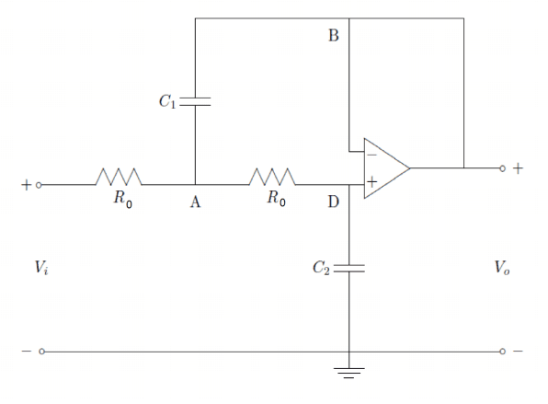Figure 4. Plant circuit

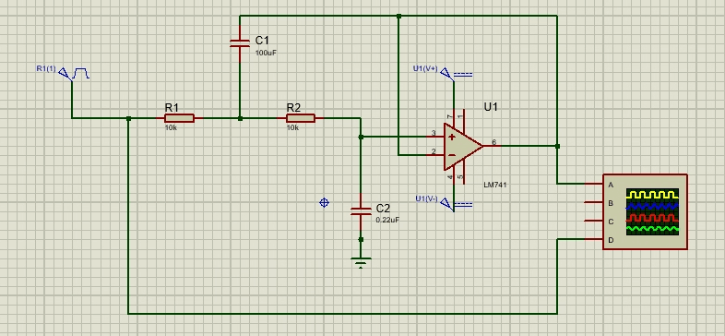And the figure below (Figure 5) is the circuit for the software.

Figure 5. Software circuit

* Impulse response: A = 1V, width = 0.1s, *f* = 1Hz. (1 Picture)
* Step Response: A = 1V, *f* = 1Hz. (1 Picture)

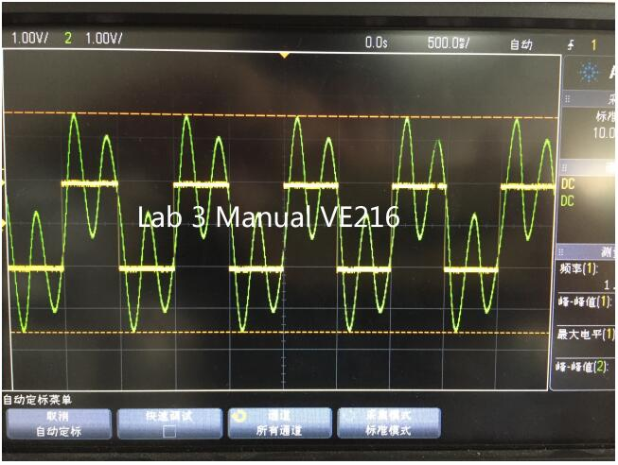For example, for the step response, we should try to get something like the waveform shown in following figure (Figure 6).

Figure 6. Example result of plant

**Note 1: Do not destroy the plant circuit after getting the image, we are going to use it in the next part.**

**Note 2: Do not forget to supply all the op-amps with DC voltage (Pin 4 (-12V) and 7 (12V)) (Figure 7)**

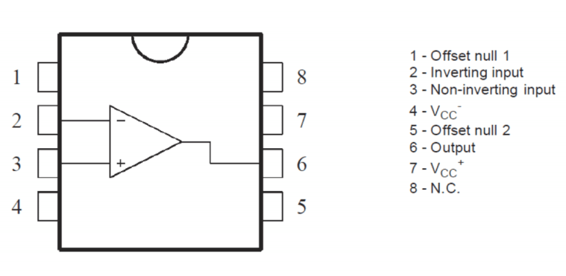**Note 3: If a capacitor is labeled “474”, its capacitance is $47×{10}^{4}$ pF; “224” is $22×{10}^{4}$ pF**

Figure 7. Op-amp

* 1. **Feedback Control**
* 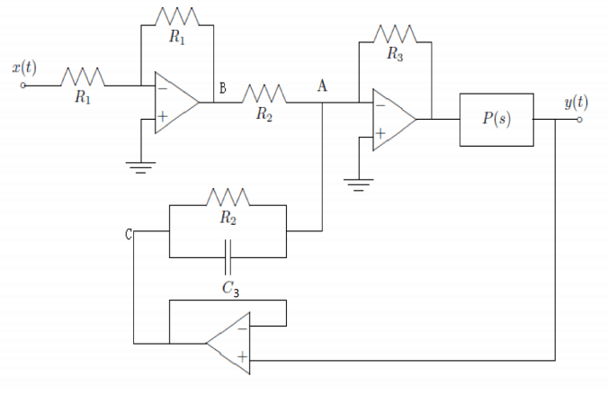Add the feedback control circuit to the plant according to Figure 7 (Figure 8). Where $R_{1}$ = $R_{3}$ = 150kΩ, $R_{2}$ = 3kΩ, $C_{3}$ = 0.47*µ*F.

Figure 8. Feedback control circuit

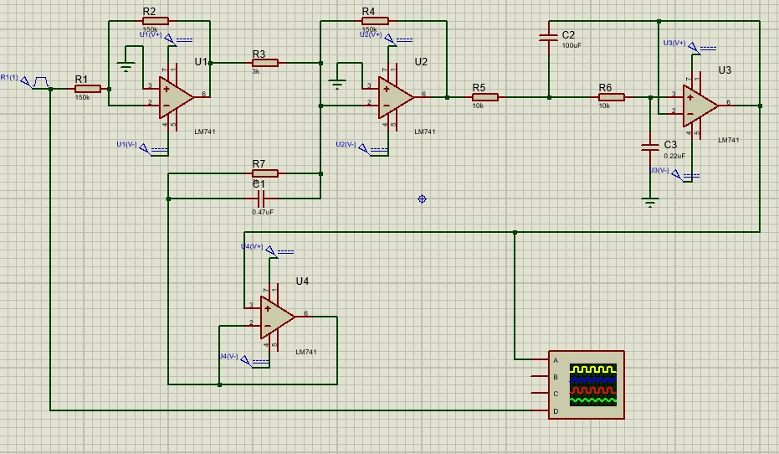And the figure below (Figure 9) is the circuit for the software.

Figure 9. Software circuit

* Impulse response: A = 1V, width = 0.1s, *f* = 1Hz. (1 Picture)
* Step Response: A = 1V, *f* = 1Hz. (1 Picture)

For example, for step response, we should try to get something like the waveform shown in the following figure (Figure 10).

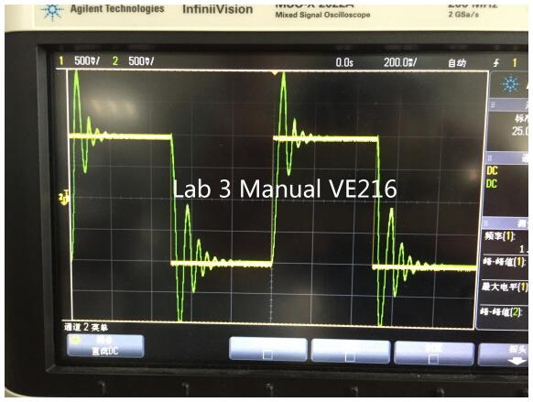Figure 10. Example result of feedback control

1. **Experiment results**
   1. 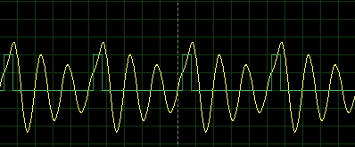**Open Loop Control—Plant**

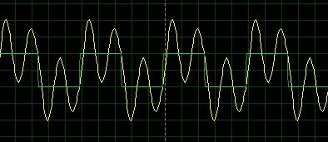Figure 11. Result for impulse response

Figure 12. Result for step response

* 1. 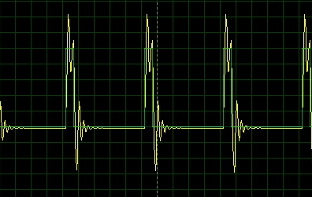**Feedback Control**

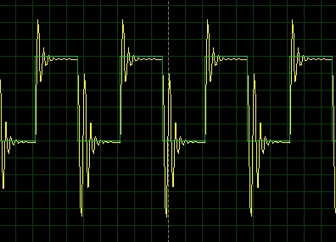Figure 13. Result for impulse response

Figure 14. Result for step response

1. **Error analysis & Discussion**

Generally, the shape of the figures we get is similarly to what the example given in section 3. Since the experiment is conducted via software, the main reason for error is wrong connection of the circuit or the reading of oscilloscope.

1. **Conclusion**

From this lab, we have a better understanding of feedback control.

First, we build the open loop control—plant circuit, and then get the figure for impulse response and step response.

Then, we build the feedback circuit, and then get the figure for impulse response and step response.

1. **Reference**

[1] Lab+3+Manual.pdf

[2] PreLab3_SU2020.pdf